|  |  |
| --- | --- |
| \\VFILERDPI\DPI-Home\OBRIENR2\My Documents\Downloads\PP logo.jpg |  |
| **COUNCIL ASSESSMENT REPORT**  SOUTHERN REGIONAL PLANNING PANEL | |

|  |  |
| --- | --- |
| PANEL REFERENCE & DA NUMBER | PPSSTH-139 – DA10.2021.38711.1 |
| PROPOSAL | Alterations and Additions to Albury Base Hospital - Redevelopment of Emergency Department |
| ADDRESS | Lot 14 DP 1175382 at 201 Borella Road, East Albury |
| APPLICANT | Habitat Planning on behalf of the Victorian Health and Human Services Building Authority |
| OWNER | NSW Department of Health |
| DA LODGEMENT DATE | 18 August 2021 |
| APPLICATION TYPE (DA, Concept DA, CROWN DA, INTEGRATED, DESIGNATED) | Crown DA  ‘Integrated Development’ pursuant to Section 4.46 of the Act and Section 100B of the Rural Fires Act. |
| REGIONALLY SIGNIFICANT CRITERIA | Clause 4, Schedule 7 of the SRD SEPP: Development carried out by or on behalf of the Crown (within the meaning of Division 4.6 of the Act) that has a capital investment value of more than $5 million. |
| CIV | $24,185,954.00 (excluding GST) |
| CLAUSE 4.6 REQUESTS | N.A. |
| KEY SEPP/LEP | Infrastructure SEPP, SRD SEPP, Albury LEP 2010 |
| TOTAL & UNIQUE SUBMISSIONS KEY ISSUES IN SUBMISSIONS | One (1)  Lack of Parking and pedestrian access |
| DOCUMENTS SUBMITTED FOR CONSIDERATION | [Plans, reports, Clause 4.6] |
| SPECIAL INFRASTRUCTURE CONTRIBUTIONS (S7.24) | N.A. |
| RECOMMENDATION | Approval |
| DRAFT CONDITIONS TO APPLICANT | YES |
| SCHEDULED MEETING DATE | 23 March 2022 |
| PLAN VERSION | A00-001 COVER SHEET 01/04/2021  A02-001 EXISTING SITE CONTEXT 01/04/2021  A02-002 EXISTING SITE CONTEXT PLAN 01/04/2021  A02-003 EXISTING SITE PLAN 01/04/2021  A02-010 EXISTING CONDITIONS PLAN - LEVEL 02 01/04/2021  A10-001 PROPOSED SITE CONTEXT PLAN 01/04/2021  A10-002 PROPOSED SITE PLAN 01/04/2021  A12-001 DEMOLITION PLAN 01/04/2021  A20-001 OVERALL FLOOR PLAN LEVEL 02 01/04/2021  A22-001 FLOOR PLAN 01/04/2021  A27-001 LEVEL 02 FIRE COMPARTMENTATION PLAN 01/04/2021  A30-001 REFLECTED CEILING PLAN - LEVEL 02 01/04/2021  A40-001 ROOF PLAN 01/04/2021  A40-002 PLANT ROOF PLANT 01/04/2021  A50-001 ELEVATIONS 01/04/2021  A51-001 SECTIONS 01/04/2021  A61-001 FIT-OUT PLAN - SOUTH 01/04/2021  A61-002 FIT-OUT PLAN - NORTH 01/04/2021  A99-001 ED EXPANSION AXONOMETRIC VIEW 01/04/2021 A99-002 SSU AXONOMETRIC VIEW 01/04/2021  LDD01 LANDSCAPE DESIGN DEVELOPMENT REV DD1 31/03/21  LCD02 LANDSCAPE EARLY WORKS – STAFF LOUNGE COURTYARD DETAILS REV T1 11/05/2021  LCD03 TECHNICAL NOTES 1 REV T1 11/05/2021  LCG04 TECHNICAL NOTES 2 REV T1 11/05/2021 |
| PREPARED BY | STH Architects (Development Plans)  Land Design Partnership (Landscape plans) |
| DATE OF REPORT | 31 January 2022 |

**EXECUTIVE SUMMARY**

This application has been lodged by Habitat Planning on behalf of the Victorian Health and Human Service Building Authority (VHHSBA for the redevelopment and expansion of the Emergency Department (ED) at the Albury Base Hospital. The development is a collaboration of the New South Wales & Victorian Governments, working with the cross-border health service provider, Albury Wodonga Health (AWH) for the consolidation and expansion of the Emergency Departments and its services at the Albury Base Hospital site in East Albury. The redevelopment of the ED will consolidate and significantly expand ED services at the Albury campus to meet current and emerging health service demands of the broader community.

The project is a Crown development that has a Capital Investment Value (CIV) greater than $5 million and is a type of *health services facility*. Under the provisions of *State Environmental Planning Policy (State and Regional Development) 2011* (SRD SEPP) the development is a Regionally Significant Development (RSD).

The design response has been developed through extensive consultation and informed medical design input and will be undertaken in two main stages that will firstly see a new ED constructed in Stage 1 followed by the refurbishment of the existing ED in Stage 2.

The development includes demolition works and construction of a single storey addition that will result in a new ED comprising:

* 42 additional Points of Care (POC)
* 16 emergency short stay beds
* Four new covered Ambulance bays
* Four parking bays in addition to dedicated police vehicle bays
* Discrete access to behavioural assessment rooms
* Reconfigured access and carpark

1. **THE SITE AND LOCALITY**
   1. **The Site**

The subject site, identified in the location map below, comprises the Albury Base Hospital precinct, which is located at 201 Borella Road, East Albury. The single parcel of land is owned by the NSW Ministry of Health. It has a total area 8.46 hectares and is occupied by the regionally significant Albury Base Hospital, Albury Wodonga Regional Cancer Centre and associated allied health facilities. The site is bound by Borella Road to the north, Keene Street to the west, East Street to the east and Eastern Hill bushland reserve to the south. The precinct is located approximately 2 km north-east of the Albury CBD, 7km northeast of the Wodonga CBD, 3km south of the Lavington CBD and 7 kilometres southwest of the Thurgoona growth corridor.

The topography of the land is described as having a gentle fall from the base of Eastern Hill Reserve at the south to Borella Road at the north at an average grade of approximately 3 degrees. Overall, the site has a 12m fall over a 300m depth providing excellent northerly aspect and good internal amenity within a series of courtyard spaces between built forms. The site drains to the northeast via existing pipe and pitted infrastructure within the East Street and Borella Road reserves.

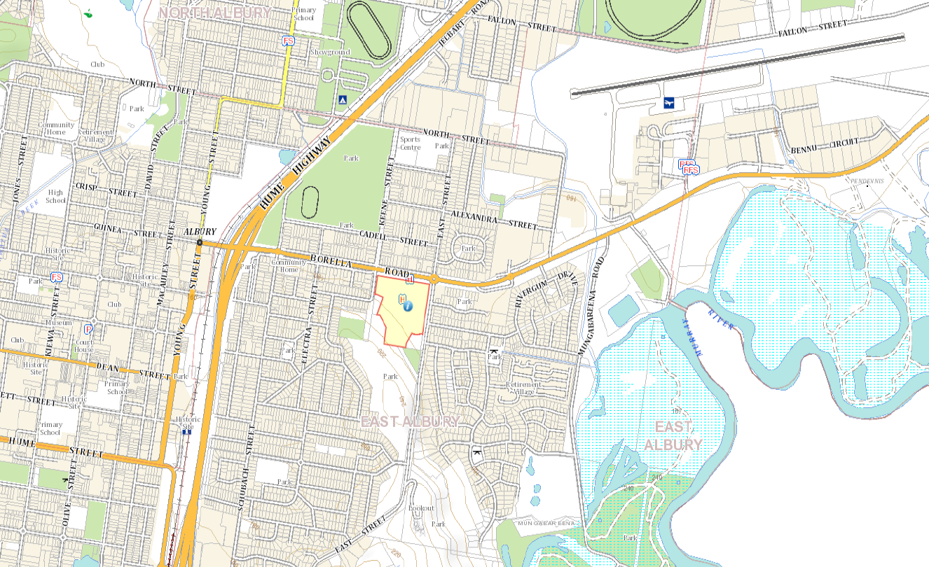Locality Plan

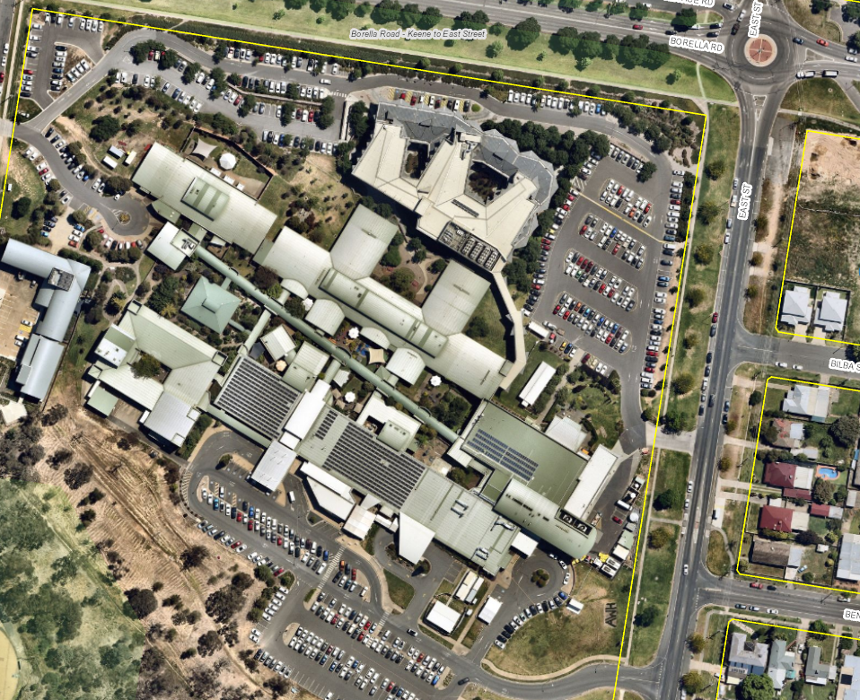Site conditions

* 1. **The Locality**

The land surrounding the Hospital campus is predominantly residential in nature, particularly to the east, west and south (beyond Eastern Hill Reserve). The area is characterised by a variety of single and medium density style dwellings and is noted as an area of transition in residential densities. There are also a number of commercial land uses located to the north along Borella Road which forms part of the local neighbourhood centre precinct, commonly referred to as ‘Newmarket’. The site is adjoined as follows:

To the north:

Borella Road (which is a classified “state” road), forms part of the east-west corridor of the Riverina Highway and abuts the northern boundary of the Hospital site. This section of Borella Road is a four-lane arterial road and has a service road running parallel at the north. This service road provides access to a small-scale neighbourhood centre comprising a variety of local shops and an independent supermarket. Further north is predominantly attached and detached single and multi-dwelling housing. The Lauren Jackson Sports Centre is located approximately 800m to the north, with industrial land uses located further north.

To the south:

The site is at the base of the Eastern Hill Reserve, which is a dominant landscape feature in the neighbourhood. The Reserve forms part of the Eastern Hill range which extends to Doctors Point and the Murray River to the south. The southwestern side of the site contains a steep gradient of 10m across 122m, and an additional 10m higher across an extended 63m. The Eastern Hill Reserve abutting is environmental land comprises of native woodland vegetation and significant water supply reservoirs. Further to the south and beyond the Eastern Hill reserve is conventional residential housing development in the suburb of East Albury.

To the east:

Immediately to the east of the site is conventional residential housing development within the suburb of Eastern View Estate. Further east of the residential estate is the Murray River, located approximately 1.5km from the hospital site. The Albury Airport is located approximately 1.8km to the northeast of the site.

To the west:

Immediately to the west of the site is conventional residential housing development within the suburb of East Albury. The immediate locality is made up of single and multi-dwelling houses in a conventional residential neighbourhood. Located further to the west is the Hume Freeway and full diamond interchange and the Inland Rail corridor. Approximately 2km further west is the Albury CBD.

1. **THE PROPOSAL AND BACKGROUND** 
   1. **The Proposal**

This application seeks Development Consent for the redevelopment and extension of the Emergency Department of the Albury Base Hospital. The development includes demolition works and construction of a single storey addition to the south of the existing emergency department and comprises an additional 2,005m² of Gross Floor Area (GFA). The Development Application seeks approval for the development to be carried out in two stages.

The first stage of the redevelopment seeks to construct the new ED whilst ensuring the continued safe and responsive health services with the operation of the existing ED. The development will provide a significantly expanded service to meet current and future health demands in the catchment.

The Stage 1 extension is made up of the following elements:

* New reception, waiting areas and triage rooms
* New staff offices and amenities
* New acute treatment rooms
* Resuscitation Zone
* Construction of new ambulance and emergency vehicle bays and access areas
* Associated pedestrian and vehicular access upgrades
* New landscape works
* Service and utility connections and augmentation

The application seeks to demolish and remove, within the proposed building footprint, all external hardstand areas including bitumen driveways, carparks, kerb and gutter, helipad and canopy cover over existing ambulance bays. The development will also remove all landscaping within the areas located adjacent to the existing ED entrance and frontage of the existing ED. The demolition works will facilitate the new ED extension works with initial working comprising underground service provisioning including plumbing, electrical and drainage and will also prepare the building footprint for building and construction works associated with the ED extension.

|  |
| --- |
| Existing Site Plan |
| Proposed Site Plan |

Upon the completion and commissioning of the new ED, the old ED will be closed for Stage 2 works of the redevelopment. This staged approach is necessary to enable the orderly transition of the ED operations and the future relocation of critically inter-dependent acute services to the Albury campus within close physical proximity to the redeveloped ED. The staging of the works will ensure service levels are maintained during the construction period. Stage 2 will commence once first stage is completed and operational and decanting of ED has been finalised.

 Stage two work includes internal demolition to the existing ED area to facilitate:

* 16 emergency short stay beds
* New ED Administration zone
* New offices, meeting rooms and collaboration spaces
* New equipment storage and designated linen disposal areas.

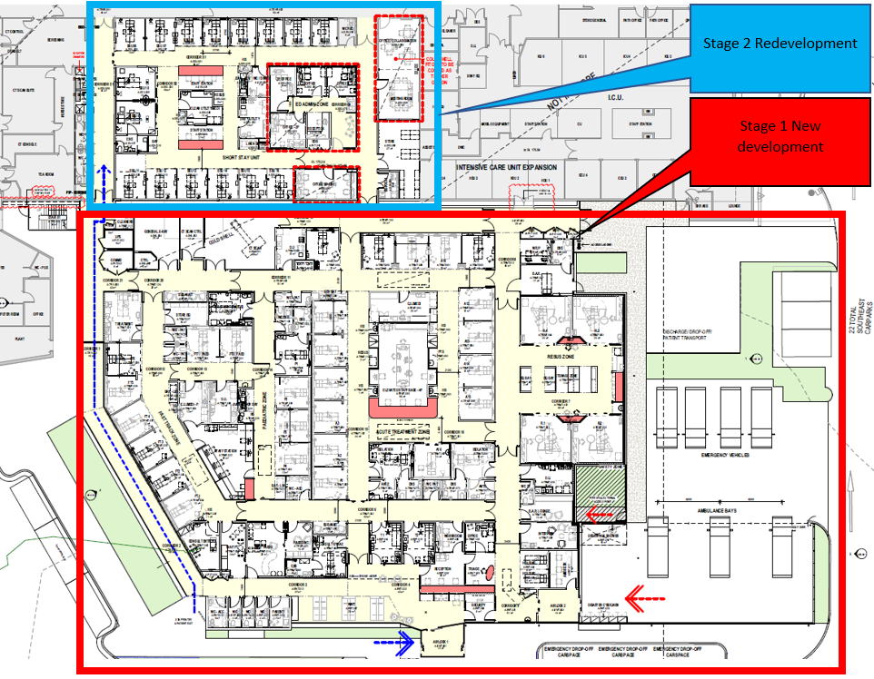 Proposed floorplan showing new development (Stage 1 – Red) and redevelopment (Stage 2 – Blue)

Ultimately, the proposed development will result in a new and redeveloped ED comprising:

* 42 new Points of Care
* 16 emergency short stay beds
* Four new covered Ambulance bays
* Four parking bays in addition to dedicated police vehicle bays
* Discrete access to behavioural assessment rooms
* Additional X-Ray and CT Scanning spaces,
* Behavioural assessment rooms
* Private family consult rooms
* Administration and offices

The outside of the building will be constructed of compatible materials and finishes which contrast and complement the finishes of the existing facility including the use of terracotta Rainscreen Cladding and custom design perforated sheet metal cladding powder-coated with a terracotta finish. Clear glazed panels with a fritted pattern in a vertical arrangement will clad the southern facades of the single storey structure

New emergency drop-off car spaces and landscaping will be located adjacent to the frontage with appropriate wayfinding features and signage to the main ED entrance.

Full details of the proposal are shown in the development plans (included in attachment 1) and described in the Statement of Environmental Effects (included as attachment 2).

**Table 1: Development Data**

|  |  |
| --- | --- |
| **Control** | **Proposal** |
| Site area | 8.46 ha |
| GFA | 2,005m² additional floor area |
| Clause 4.6 Requests | No |
| No of apartments | N.A. |
| Max Height | 7.5m |
| Car Parking spaces | 607 (-47 spaces removed as a result of the ED development footprint and associated with civil works |
| Setbacks | >70m |
|  |  |

* 1. **Background**

A pre-lodgement meeting was held prior to the lodgement of the applicant on 4 August 2021 where various issues were discussed. A summary of the key issues and how they are addressed is outlined below:

|  |  |  |
| --- | --- | --- |
| No. | Issue | Design Response |
| 1 | Likely constitutes regionally significant  development | Confirmed. The development is a Crown  development for a health services facility and has a CIV exceeding $5 million. The development is declared an RSD. |
| 2 | 2. Identified car parking as a major issue:  a. Steve Swan (Spotto Consulting) –  traffic impact assessment looking  to attempt to deal with the  deficiency in car parking;   * Consider comparable facilities; * Unique nature of operations; * Alternative parking arrangements; * Consider a parking structure;   b. no additional access points  proposed;  c. Consider the Borella Road /  Highway corridor strategy (and  East Street):Recommend discussion with  Traffic & Transport, including  consideration of parking on  enhanced street parking  arrangements;  d. Site access for car parking  purposes may be an issue owing to  access closures (gate closures at  accesses) associated with heliservices  to the site. | A Traffic Impact Assessment Report (TIAR) has been prepared by Spotto Consulting and is provided in Appendix 2. The TIAR addresses the unique operations of the ED, alternate options and arrangements and considers a parking structure.  It is confirmed that the development does not  propose any additional vehicle access points to or from a public road. This SEE considers and addresses the Borella Road Riverina Highway Corridor Strategy. Car parking consideration are addressed within the  TIAR and this SEE.  The existing helipad is being removed as part of the development also removing any gated  closures and access conflicts. |
| 3 | Infrastructure contributions: Cost summary report is being prepared; | Noted  A Quantity Surveyors Report is provided under separate cover. |
| 4 | Some exempt and complying  development | Noted. A minor works development with the  refurbishment of staff amenities in the existing  ED was identified as Complying Development  and is excluded from the scope of works  considered by this Development Application. |
| 5 | It was acknowledged that East St  residents may have interests regarding  amenity (aesthetics) associated with the  building; | Part 3 of the DCP and the Community  Participation Plan (CPP) provides details for  notification of development applications. The  proposal is not identified as a type of  development exempt from notification and  therefore will be notified in accordance with the requirements of the CPP.  The application provides an architectural design response that is considered to address the built form in the neighbourhood in the context of the hospital site. |
| 6 | Utility system capacity should be  considered: particularly with respect to  wastewater (consider discussing further  with Greg Whorlow / Brad Willis);  preparation of a servicing report for  sewerage and trade waste; | The application civil design documentation  package has been prepared in consultation with Council Engineers. |
| 7 | Overhead power and street lighting  should be considered in the design,  particularly when considering relocation  of helipad (Essential Energy); | Noted.  The relocation of helipad does not from part of  the scope of this Development Application. |
| 8 | Infrastructure contributions are a  significant consideration: additional  information is to be provided in order to  obtain some indication of potential  contributions; | Noted. |
| 9 | Application referral agencies likely to  include:  a. RFS;  b. Transport for NSW;  c. CASA; and  d. Police/Emergency services). | Noted.  The application is ‘Integrated Development’  pursuant to Section 4.46 of the Act and Section 100B of the Rural Fires Act. |

The development application was lodged on 18 August 2021. A chronology of the development application since lodgement is outlined below including the Panel’s involvement (briefings, deferrals etc) with the application:

**Table 2: Chronology of the DA**

|  |  |
| --- | --- |
| **Date** | **Event** |
| 18 August 2021 | DA lodged |
| 21 August 2021 | Exhibition of the application |
| 18 August 2021 | DA referred to external agencies |
| 25 November 2021 | Request for Information from Council to applicant |
| 12 December 2021 | DA lodged for car park on adjacent land |
| 14 February 2022 | DA presented to Council |
| 16 February 2022 | Panel briefing |
| 23 March 2022 | Final Panel briefing |
|  |  |
|  |  |
|  |  |

* 1. **Site History**

Albury Wodonga Health (AWH) was established in July 2009 and is the first cross border public health service to exist in Australia. Operating under an Intergovernmental Agreement between the New South Wales and Victorian governments it provides the largest regional health care service between Sydney and Melbourne.

The State of New South Wales and the State of Victoria have entered into an intergovernmental agreement to enable the cross-border integration of health services in the Albury Wodonga area. As part of this, AWHhas responsibility for the delivery of hospital services at the Albury Hospital campus. The memorandum of understanding is attached to this report.

AWH provides a range of speciality health services to a catchment that extends from north-eastern Victoria into southern NSW and a catchment population of over 250,000. The Albury Base Hospital site focuses on emergency, acute services and mental health inpatient services, providing specialist services including emergency department, critical care, cardiac catheterisation service, cancer centre and inpatient services for surgical, medical and psychiatric patients. The Emergency Department (ED) at the Albury Base Hospital presently services over 67,000 patients annually. In order to meet the future health needs of the community, the New South Wales and Victorian governments are working together to establish a new emergency department and the first Short Stay Unit (SSU) to meet the future health needs of the community.

The proposed new ED will provide a significantly expanded services to meet current and future health demands in the catchment. The new facility will include a specialised resuscitation hub, paediatric treatment area, acute treatment area, and multiple triage rooms with their own accompanying waiting rooms. Additional ambulance bays, X-Ray and CT Scanning spaces, behavioural assessment rooms and private family consult rooms are also included in the project.

The major outcome of the proposed redevelopment will be the consolidation and expansion of ED services on the Albury campus to meet current and emerging demands. It will enable the future relocation of critically inter-dependent acute services to the Albury campus within close physical proximity to the redeveloped ED by creating an infrastructure footprint to support an expanded acute services profile.

1. **STATUTORY CONSIDERATIONS**

When determining a development application, the consent authority must take into consideration the matters outlined in Section 4.15(1) of the *Environmental Planning and Assessment Act 1979* (‘EP&A Act’). These matters as are of relevance to the development application include the following:

1. *the provisions of any environmental planning instrument, proposed instrument, development control plan, planning agreement and the regulations*
2. *the likely impacts of that development, including environmental impacts on both the natural and built environments, and social and economic impacts in the locality,*
3. *the suitability of the site for the development,*
4. *any submissions made in accordance with this Act or the regulations,*
5. *the public interest.*

These matters are further considered below.

It is noted that the proposal is considered to be (which are addressed elsewhere in this report):

* Integrated Development (s4.46) – Requires consent under the Rural Fires Act 1997. General Terms of Approval issued on 29 September 2021
* Requiring concurrence/referral (s4.13) – Referral to Transport for NSW under SEPP Infrastructure 2007. Referral received and attached.
* Crown DA (s4.33) - written agreement from the Crown to the proposed conditions of consent to be provided.
  1. **Section 4.15(1)(a)(i) - Provisions of Environmental Planning Instruments**

The following Environmental Planning Instruments are relevant to this application

* *State Environmental Planning Policy No. 55 – Remediation of Land;*
* *State Environmental Planning Policy (State and Regional Development) 2011*
* *State Environmental Planning Policy (Infrastructure) 2007;*
* *Albury Local Environmental Plan 2010*

A summary of the key matters for consideration arising from these State Environmental Planning Policies are outlined in **Table 3** and considered in more detail below.

**Table 3: Summary of Applicable State Environmental Planning Policies** (Preconditions in **bold**)

|  |  |  |
| --- | --- | --- |
| **EPI** | **Matters for Consideration** | **Comply (Y/N)** |
| SRD SEPP | * Clause 4, Schedule 7 of the SRD SEPP: Development carried out by or on behalf of the Crown (within the meaning of Division 4.6 of the Act) that has a capital investment value of more than $5 million. | Y |
| SEPP 55 | * Clause 7 - Contamination and remediation has been considered in the Contamination Report and the proposal is satisfactory subject to conditions. | Y |
| Infrastructure SEPP | * Clause 101   Development with frontage to classified road. Referral response from TfNSW attached | Y |

*State Environmental Planning Policy (State and Regional Development) 2011*

*State Environmental Planning Policy (State and Regional Development) 2011* (‘SRD SEPP’) applies to the proposal as it identifies if development is regionally significant development. In this case, pursuant to Clause 20(1) of SRD SEPP, the proposal is a regionally significant development as it satisfies the criteria in Clause 4 of Schedule 7 of the SRD SEPP as the proposal is development carried out by or on behalf of the Crown (within the meaning of Division 4.6 of the Act) that has a capital investment value of more than $5 million.Accordingly, the Southern Regional Planning Panel is the consent authority for the application. The proposal is consistent with this Policy.

*State Environmental Planning Policy No. 55 – Remediation of Land*

The provisions of *State Environmental Planning Policy 55* *- Remediation of Land* (‘SEPP 55’) have been considered in the assessment of the development application. Clause 7(1) of SEPP 55 requires consent authorities to consider whether the land is contaminated, and if the land is contaminated, it is satisfied that the land is suitable in its contaminated state (or will be suitable, after remediation) for the purpose for which the development is proposed to be carried out.

The subject site is an existing urban development within an established residential area of the city and has been used for the purposes of a hospital for many years. There are no uses or activities presently contained within the site, which are potentially contaminating.

The surrounding urban land also indicates no likely contaminating uses being present. The site is not listed on AlburyCity’s Contaminated Land List. The land is considered fit for use for its intended purposes and the proposal complies with the relevant considerations of SEPP 55.

*State Environmental Planning Policy (Infrastructure) 2007*

State Environmental Planning Policy (Infrastructure) 2007 (Infrastructure SEPP) aims to facilitate the effective delivery of infrastructure across the State by improving regulatory certainty and efficiency through a consistent planning regime for infrastructure and the provision of services by providing greater flexibility in the location of infrastructure and service facilities. *Clause 104* of SEPP infrastructure states that Hospital development is traffic-generating development where ‘an enlargement or extension of existing premises, being an alteration or addition of the relevant size or capacity’ exceeds the threshold outlined in Column 1 of the Table to Schedule 3 which for a hospital equates to 200 beds.

As described above, the proposed development comprises an additional 42 beds and does not exceed the relevant size or capacity for traffic generating development. Accordingly, the proposed development is not classified as a ‘traffic generating development’ for the purposes of *Schedule 1* of this SEPP.

The site does however have frontage to a classified “state” road (Borella Road/Riverina Highway) and as a result was referred to Transport for NSW, who responded on 31 January 2022, noting the following:

* *Borella Road forms part of the Riverina Highway within Albury. Access to the development site and parking along the frontage of the site to Borella road is not permitted,*
* *The development does not propose any changes to the location of the existing vehicular access arrangements which are currently to East and Keene Streets,*
* *The proposal includes the deletion of 47 car parking spaces from the hospital campus and the development of demand for an additional 46 spaces being a net impact of 93 spaces. It appears that on-street parking within close proximity to the hospital campus is in high demand,*
* *It is understood that DA10.2021.39058.1 has been submitted for nearby land located on the corner of East Street and Borella Road to construct a 103 space carpark with gated access to be leased for use for staff from the hospital. This would appear to offset the impact of the lost parking on the hospital campus if managed appropriately.*
* *The Statement of Environmental Effects prepared by Habitat Planning acknowledges that the development of a Masterplan is critical to a holistic and long-term solution to address the current constraints and existing inadequacies of the Hospital site including carparking and the short-term impacts on the surrounding residential neighbourhood.*

Transport for NSW raised **no objection** to the proposed development, subject to the construction of the temporary carpark as per DA10.2021.39058.1.

*Albury Local Environmental Plan 2010*

The relevant local environmental plan applying to the site is the *Albury Local Environmental Plan 2010* (‘the LEP’). The aims of the LEP include:

*(aa) to protect and promote the use and development of land for arts and cultural activity, including music and other performance arts,*

*(a) to give effect to the desired outcomes, principles and actions contained in the Council’s adopted strategies and policy documents, and*

*(b) to promote sustainable urban development by providing for efficient management of urban growth and resource utilisation, and*

*(c) to promote a city for the people, with a high level of social and physical amenity and a diversity of activities and uses, and*

*(d) to maintain or improve biodiversity across Albury, and to avoid significant impacts on matters of environmental significance*.

The proposal is consistent with these aims as the proposal effects the growth of a critical community health facility, through a high level of social and physical amenity within an area of diverse activities and uses.

*Zoning and Permissibility (Part 2)*

The site is located within the “Special Purpose Zone” (SP2 – Health Services Facility) pursuant to Clause 2.2 of the LEP.

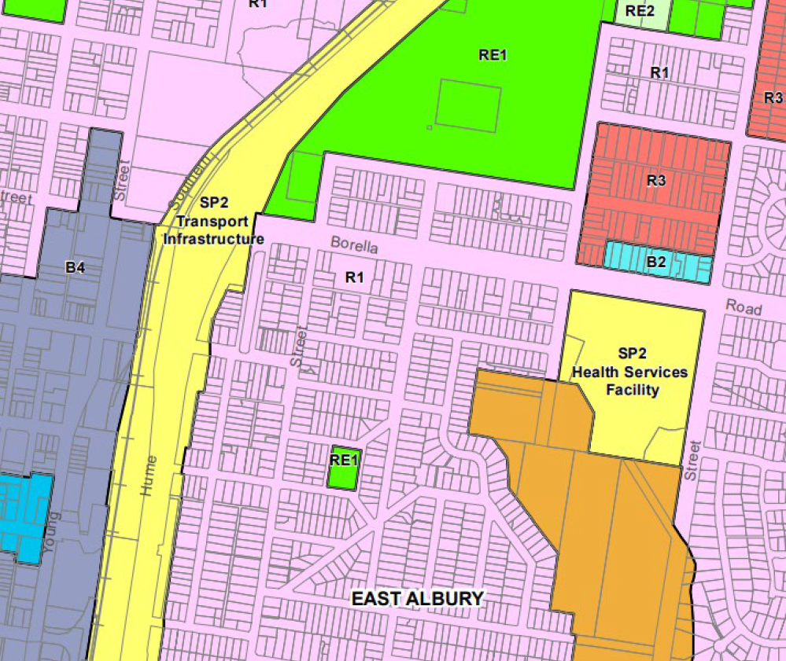Zoning map extract

SITE

According to the definitions in the LEP Dictionary, the proposal satisfies the definition of ***health services facility*** which is consistent with the purpose of the zone shown on the Land Zoning Map.

The zone objectives include the following (pursuant to the Land Use Table in Clause 2.3):

* *To provide for infrastructure and related uses.*
* *To prevent development that is not compatible with or that may detract from the provision of infrastructure.*

The proposal is considered to be consistent with these zone objectives as it continues to provide regionally significant health services facility infrastructure associated with the Albury Base Hospital. The proposed new ED represents a ‘health services facility’, which is permitted with development consent in the SP2 Infrastructure zone as it relates to the defined purpose.

The development provides for essential and important community infrastructure and is consistent with the objectives for the zone.

*General Controls and Development Standards (Part 2, 4, 5, 6 and 7)*

Clause 2.7 - Demolition

Clause 2.7 of the LEP states that demolition of a building or work may be carried out only with development consent. This proposal involves demolition works to the existing building and constructed surfaces as identified in the demolition plans as included in the attached plan set. The application details the extent of demolition which is proposed and required to facilitate the redevelopment works for the property.

Clause 7.1 - Earthworks

Clause 7.1 of the LEP relates to earthworks and applies in this instance as the excavation works are not classified as exempt development under *State Environmental Planning Policy (Exempt and Complying Development Codes) 2008*. Consequently, consent is required for the earthworks and the provisions of this clause require consideration.

Before development consent can be granted, the following matters must considered:

1. *the likely disruption of, or any detrimental effect on, existing drainage patterns and soil stability in the locality of the development,*
2. *the effect of the development on the likely future use or redevelopment of the land,*
3. *the quality of the fill or the soil to be excavated, or both,*
4. *the effect of the proposed development on the existing and likely amenity of adjoining properties,*
5. *the source of any fill material and the destination of any excavated material,*
6. *the likelihood of disturbing relics,*
7. *the proximity to and potential for adverse impacts on any watercourse, drinking water catchment or environmentally sensitive area.*

The proposed development is consistent with these matters for consideration as follows:

* It will not adversely affect existing drainage conditions or soil stability in the area as it does not involve works to an existing drainage line. Furthermore, the development will be undertaken in accordance with a sediment and erosion control plan and the land will be stabilised and rehabilitated;
* The purpose of the works is to allow for the redevelopment of the new ED;
* Any fill imported to the site will be clean virgin fill;
* The works are not expected to have an adverse amenity impact on adjoining properties (or the function of the existing hospital) due primarily to the minor scale of the proposed earthworks and measures to be implemented to mitigate any impact;
* Where excavation is required as part of the demolition and/or construction works, all excavated material will be stockpiled on site. Any material to be removed from the site will be taken to a registered landfill (Albury Waste Management Centre);
* The likelihood of disturbed relics is considered low given the developed nature of the site; and
* The subject land is not classified as an environmentally sensitive area, nor will it adversely affect a drinking water catchment.

Clause 7.6 – Essential Services

Clause 7.6 of the LEP refers to essential services and aims to ensure that all relevant services are available to the site. Development consent must not be granted to development unless the consent authority is satisfied that any of the following services that are essential for the proposed development are available or that adequate arrangements have been made to make them available when required:

* 1. *the supply of water,*
  2. *the supply of electricity,*
  3. *the disposal and management of sewage,*
  4. *stormwater drainage or on-site conservation,*
  5. *suitable road access.*

As confirmed above the site is within an established urban area of Albury with existing suitable access and connection to reticulated water, sewer and electricity infrastructure, urban stormwater drainage and public road access. Internal services may be realigned and connected where necessary within the Lot boundaries. In consultation with the applicable service providers, all services are confirmed to have suitable capacity for minor augmentation work as required.

The LEP contains no other specific controls relating to the site or proposed development. Notwithstanding, the proposal is considered to be generally consistent with the LEP. It is specifically noted that, under Clause 5.12 of the LEP, this plan does not restrict or prohibit, or enable the restriction or prohibition of, the use of existing buildings of the Crown by the Crown.

* 1. **Section 4.15 (1)(a)(ii) - Provisions of any Proposed Instruments**

There are no proposed instruments which have been the subject of public consultation under the EP&A Act, which may be relevant to the proposal.

* 1. **Section 4.15(1)(a)(iii) - Provisions of any Development Control Plan**

The following Development Control Plan is relevant to this application:

The Albury Development Control Plan 2010 (“the DCP”) provides specific a guideline for development within the Albury City Local Government Area, including the subject site. Section 4.15(3A) of the EP&A Act requires a consent authority to apply its DCP provisions flexibly and allow reasonable alternative solutions that achieve the objects of those standards.

The following chapters of the DCP are applicable to the proposed development:

* Part 4 – Developer Contributions
* Part 6 – Planning for Hazards
* Part 14 – Development in the Special Purposes Zone
* Part 17 – Off-street parking

The below details provide an overview of consistency and compliance of the proposal against the relevant chapters of the DCP.

Part 4 – Developer Contributions

Part 4 of the DCP provides details regarding the payment of developer contributions under Section 7.11 or 7.12 of the *Environmental Planning and Assessment Act* and/or Section 64 of the *Local Government Act 1993*, to provide Council with funds to provide coordinated infrastructure and services for the City. Developer Contributions will be levied in accordance with the requirements of the *Albury Infrastructure Contributions Plan 2014* (ICP).

Section 3.7.1 of the ICP lists development exempted from both Sections 7.11 and 7.12 contributions levies under this plan. Places of worship, **public hospitals and emergency services** are included in the list of exempted development.

Section 3.7.2 of the ICP states the Minister for Planning may make a determination in regard to Developer Charges levied on Crown development. Crown developments for essential community services including health and community services are exempt from general Developer Charges.

As a result, no Developer Contributions are proposed to be levied against the proposal.

Part 6 – Planning for Hazards

Part 6 of the DCP seeks to minimise the risks associated with natural hazards, including bushfire, flooding and land contamination. The subject site is not known to be contaminated not identified on the Albury Flood Planning Map as being flood prone land or land located within a Flood Planning Area.

A portion of the subject land, however, is identified as bushfire prone land (‘Vegetation Buffer’) on the Albury Bushfire Prone Land Map. The area of land, identified by the red overlay, represents a 30m wide bushfire buffer zone that extends the length of the southern boundary of the site and buffers the Category 2 Vegetation to the south on Eastern Hill Reserve.

Section 6.4 of the DCP refers to bushfire. The objectives of Section 6.2.1 are:

1. To ensure, where consent is required for subdivision and development, that the following

occurs in bushfire prone areas:

* Occupants of any building are afforded with adequate protection from exposure to a bushfire.
* A defendable space is located around buildings.
* Appropriate separation between a hazard and buildings which, in combination with other measures, prevent direct flame contact and material ignition.
* Safe operational access and egress for emergency service personnel and residents is available.
* Ongoing management and maintenance of bushfire protection.
* Measures, including fuel loads in the Asset Protection Zone (APZ), are established.
* Utility services are adequate to meet the needs of fire fighters (and others assisting in bushfire fighting).

Extract from Bushfire Prone Land Map

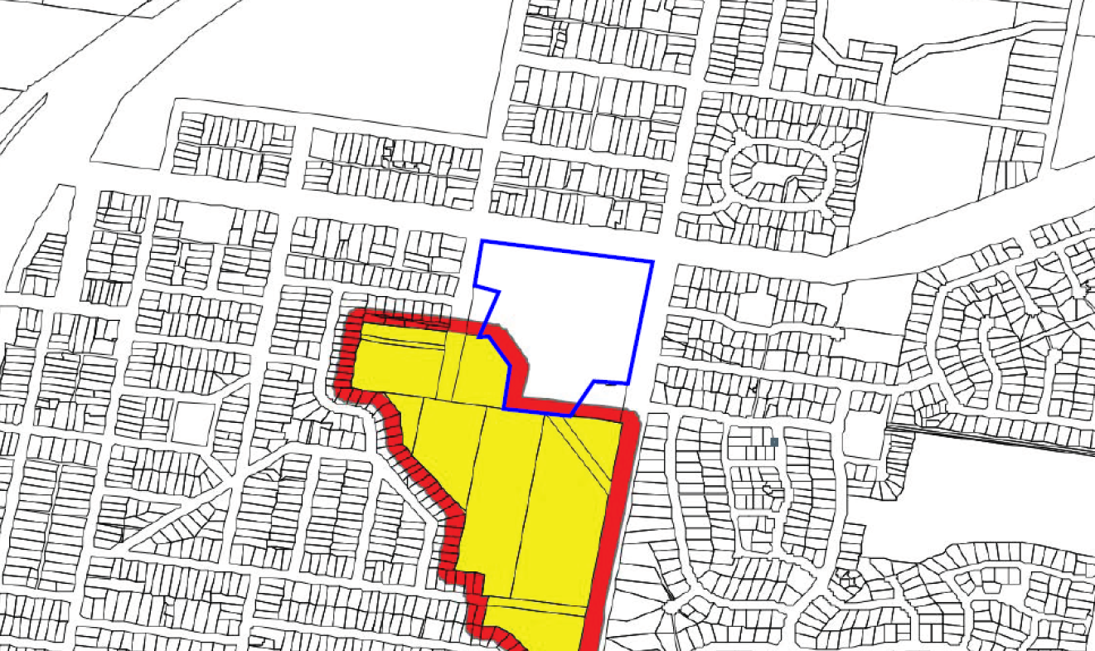

The proposed development is consistent with the objectives of Section 6.4 as the development will be set back from the adjoining bushfire hazard and maintain the required Asset Protection Zone (APZ) and appropriate road access away from the hazard and is connected to a reticulated water supply. A Bushfire Risk Assessment has also been prepared in support of the proposed application and the application was submitted to the NSW Rural Fire Service (RFS) as “integrated development, requiring a Bush Fire Safety Authority (BSA), under section 100B of the Rural Fires Act 1997. General Terms of Approval was issued by RFS on 29 September 2021 and attached to this report. The conditions of the General Terms of Approval have been included in the Draft Determination.

Overall, the proposed development is consistent with the applicable objectives and controls of Part 6 of the DCP.

Part 14 – Development in the Special Purposes Zone

The “Special Purpose Zones” are generally intended for, in the case of the SP2 Infrastructure Zone, a wide range of physical and human infrastructure uses. In this case, the Zoning Map specifically labels the site as “SP2 – Health Services Facility”.

Part 14 of the DCP confirms that where development consent is required in the SP2 Infrastructure Zone, that development will be assessed according to the zone objectives and relevant provisions of the LEP, and the EP&A Act, including provisions of *Section 4.15* and any other relevant objectives and controls in this Part or any other Part of this DCP.

Noting there are no specific controls to guide the built form of hospitals in the SP2 zone, the application has been prepared to address the relevant heads of consideration listed under Section 4.15(1) of the EP&A Act and provides an assessment of the environmental impacts and identifies the steps to be taken to protect or lessen the potential impacts on the environment is below.

Part 17 – Off-street parking

Chapter 17 of the DCP relates to car parking, and sets the requirements for various land uses, as well as other design related requirements for the operation and embellishment of car parking.

The proposed development increases the capacity of the hospital and therefore increases the demand on car parking within the site. For the purposes of calculating car parking for a hospital, the DCP requires the following:

* *1 space per 4 beds plus 1 per 2 employees.*

This development proposes 42 additional beds, and the expansion will also result in an increase in average shift staffing of 71 (from 26 to 97). Therefore, the parking required by the development is (42 beds/4 = 10.5 spaces) + (71 additional staff/2 = 35.5 spaces) = 46 additional spaces.

However, extending the building and associated civil works will also result in a reduction of 47 spaces from the existing carpark. Therefore, the result of the proposed development will be a parking shortfall of 93 spaces.

A Traffic Impact Assessment Report (TIAR) prepared by Spotto Consulting was submitted with the application and attached to this report. According to the TIAR nearby intersections and all access points to site currently operate at an excellent Level of Service (LOS A, the highest level) and:

* the midblock level of service on all roads surrounding the site is satisfactory (LOS C) or better;
* parking surveys carried out on a typical weekday show that there is a high level of demand for off-street parking at the site, with vehicles using on-street parking in the surrounding streets to meet demand;
* the proposed development is anticipated to generate 36 vehicle trips per hour in the AM and PM peak hour, which will not have a significant impact on the performance of the road network in the immediate vicinity of the site (including nearby intersections, midblock sections of road and site accesses);
* the proposed development is anticipated to require an additional 93 off-street parking spaces, consisting of 46 spaces to meet additional staff/patient requirements and 47 spaces to offset those lost through expansion of the building; and
* adequate provision has been made for ambulances and service and delivery vehicles.

However, it should be noted that the TIAR also confirmed pre-existing deficiencies that are currently being met by on-street parking availability in the surrounding street network. It is estimated that the existing shortfall in off-street parking at the site is in the order of 82 spaces. According to the TIAR, the projected parking demand shortfall cannot be fully met by this same on-street parking supply. Consequently, it is likely the increased parking deficiencies will place additional pressure upon the surrounding neighbourhood road network and on-street parking facilities. Further, the increased on-street parking will likely result in visual impacts of parked vehicles on the street and noise impacts relating to traffic movements at various times of the day especially during the peak periods.

Noting that the on-street parking availability in the immediately surrounding road networks of East Street and Keene Street are nearing capacity, the anticipated parking demands will likely extend and disburse further into the surrounding residential areas of East Albury and Eastern View Estate.

These impacts were communicated with the applicant during assessment. In response, a separate Development Application (DA 10.2021.39058.1) was lodged proposing a car park providing 103 spaces on adjacent land at the Borella Road/East Street intersection (165 & 169 Borella Road, 610 & 614 East Street and 166 Bilba Street). That Development Application has been assessed and presented to Council under separate cover. It should be noted that following the assessment, some modification to the layout was recommended and the car park will ultimately provide 105 spaces. It is considered that sufficient provision for car parking has been made to address the issues raised relating to car parking deficiencies in the short term. It is acknowledged that the temporary car park is only supported for a maximum period of 10 years. This timeframe will ensure urgency in the implementation of an on-site solution (such as a multi-deck car park building) and will reduce the likelihood of the car park use becoming ingrained in the urban fabric, which is contradictory to the objectives of that site’s residential zoning as well as the *Borella Road and Riverina Highway Corridor Strateg*y. Once the car park becomes redundant within this time, the site shall be reverted back to land suitable for permissible uses in the R1 zone.

The proposed car park is a temporary use whilst alternate options for additional parking on the Hospital site are explored by Albury Wodonga Health (AWH) with the development of a Masterplan. Works on the Masterplan have significantly advanced and is currently under review by AWH Executive. The Masterplan places a high priority on on-site, multi-storey car parking and the need for consolidated single site facility into the future. The development of the Masterplan is critical to a holistic and long-term solution to address the current constraints, including car parking and the short-term impacts on the surrounding residential neighbourhood. Importantly, this development is critical community infrastructure that the regional community desperately needs, and the Master planning process has commenced providing public confidence that these matters are recognised, and a long-term solution is being sought in the immediate term.

It was however noted that the temporary carpark included four accessible spaces for people with disabilities. As was noted in the assessment of DA 10.2021.39058.1, these spaces are not required in this location and staff with disabilities will be much better served with these spaces provided near hospital entrances. As a result, it will be required through a condition of consent that an additional four accessible spaces be provided on-site, in lieu of additional standard spaces being provided in the temporary carpark. For that reason, the total number of car parking spaces within the temporary carpark has increased from 103 to 105 (shared spaces became additional standard spaces).

It is noted that Council approved the temporary carpark (DA10.2021.39058.1) on 14 February 2022 subject to conditions.

Despite the on-site car parking numerical deficiency, the proposed car parking spaces are designed consistent with Australian Standards and Guidelines and are expected to operate satisfactorily. Adequate provision is also made for ambulances, and emergency service vehicles. Delivery, waste and service vehicles will continue to operate under existing conditions and utilise a separate East Street access point and service area. Regarding the design of the on-site car parking and access arrangements, certain technical modifications were proposed by Council, which will be discussed further under ‘Traffic flow and access’.

The existing public transport networks in the area also extend to the site with buses operating through Albury, Wodonga and Thurgoona. The site is also interconnected with the surrounding network of shared footpaths and cycleways providing access to and from bus stops to the main entrances of the hospital where end-of-trip facilities are available. Whilst reliance upon public transport accounts for a small number of visitors, it is a service that is readily available on weekdays, and its use should be promoted and encouraged. The surrounding street network also supports shared pedestrian linkages to the hospital encouraging a variety of alternate transport modes.

Traffic flow and access

It is acknowledged that the on-site car park design, including hold lines, internal pavement markings and wheel stop provisions are to be provided where appropriate and in accordance with the Australian Standard 2890.1. Similarly, all new and revised parking spaces are designed to accord with AS2890.1 with minimum dimensions 5.4m x 2.6m and aisle widths of minimum 5.8m. This will be reinforced with appropriate conditions of the consent should the SRPP approve the development.

Channelised Right turn lanes (CHR) are to be provided at both entrances to the site from East Street. The CHR for the southern car parks is to be designed in conjunction with Council, to enable the provision of a CHR into Benyon Street. The TIAR prepared by Spotto Consulting, 2021 also notes channelised right turn treatments are warranted for both site accesses on East Street. However, no dedicated turning lanes are warranted for left turns.

Pedestrian priority is to be given where any path crosses an access road, and Tactile Ground Surface Indicators (TGSI) are to be installed. All new paths should be designed to be Disability Discrimination Act compliant. All road crossing points must be designed to be perpendicular to the kerb.

* 1. **Section 4.15(1)(a)(iiia) – Planning agreements under Section 7.4 of the EP&A Act**

There have been no planning agreements entered into and there are no draft planning agreements being proposed for the site.

* 1. **Section 4.15(1)(a)(iv) - Provisions of Regulations**

Clause 92(1) of the Regulation contains matters that must be taken into consideration by a consent authority in determining a development application, comprising the following:

* *If demolition of a building proposed - provisions of AS 2601;*

These provisions have been considered and addressed in the draft conditions (where necessary).

* 1. **Section 4.15(1)(b) - Likely Impacts of Development**

The likely impacts of that development, including environmental impacts on both the natural and built environments, and social and economic impacts in the locality must be considered. In this regard, potential impacts related to the proposal have been considered in response to SEPPs, LEP and DCP controls outlined above and the Key Issues section below.

The consideration of impacts on the natural and built environments includes the following:

* Context and setting – The subject land is zoned ‘SP2’ and is located within a predominantly residential neighbourhood containing residential land uses to the east and west, and an environmental reserve containing extensive native vegetation to the south. A range of mixed and non-residential, commercial land uses currently exist within the neighbourhood centre on the northern side of Borella Road.

Appropriate interface treatments exist within the existing hospital site and the development maintains the predominantly landscaped setting. The new ED is sited to the rear of the existing hospital where the primary interface is the existing car park and environmental conservation land to the south within the Eastern Hill Reserve.

The new larger and attached building will create a high quality and positive outcome without detrimental impacts to the surrounding context and residential setting. The development retains significant landscape features and trees, access points and predominant build form and is consistent with the zoning of the land and established land use setting. The additions will integrate with the existing development and surrounding build form and the use is entirely compatible with surrounding land uses.

* Access and traffic – An assessment of relevant car parking requirements has been undertaken for the proposed development and has identified an equivalent net deficiency of 93 car parking spaces as described in the report above. In summary, the development results in an additional 42 beds and an additional 71 staff in the emergency department. This would require 46 additional car parking spaces whilst no spaces are proposed. Furthermore, the extent of the development’s increased footprint will also result in the loss of 47 spaces from the existing carpark. As a result, the total net shortfall in parking is 93 spaces.

The response to the shortfall is a separate Development Application (DA 10.2021.39058.1) that was lodged with Council in December 2022 and determined on 14 February 2022, proposing a car park providing 105 spaces on adjacent land at the Borella Road/East Street intersection. It is considered that sufficient provision for car parking has been made to address the issues raised relating to car parking deficiencies in the short term. It is noted that the temporary car park is only supported for a maximum period of 10 years to ensure urgency in the implementation of an on-site solution (such as a multi-deck car park building) and reverting the land back to enable a more desirable use in the context of its prominent location and the Borella Road and Riverina Highway Corridor Strategy.

Despite the on-site car parking numerical deficiency, the proposed car parking spaces are designed consistent with Australian Standards and Guidelines and are expected to operate satisfactorily. Adequate provision is also made for ambulances, and emergency service vehicles. Delivery, waste and service vehicles will continue to operate under existing conditions and utilise a separate East Street access point and service area. Regarding the design of the on-site car parking and access arrangements, certain technical modifications were proposed by Council, included as conditions of consent in the Draft Determination attached to this report. This includes, for example, the provision of Channelised Right turn lanes (CHR) at both entrances to the site from East Street.

The existing public transport networks in the area also extend to the site with buses operating through Albury, Wodonga and Thurgoona. The site is also interconnected with the surrounding network of shared footpaths and cycleways providing access to and from bus stops to the main entrances of the hospital where end-of-trip facilities are available. Whilst reliance upon public transport accounts for a small number of visitors, it is a service that is readily available on weekdays, and its use should be promoted and encouraged. The surrounding street network also supports shared pedestrian linkages to the hospital encouraging a variety of alternate transport modes.

According to the TIAR nearby intersections and all access points to site currently operate at an excellent Level of Service (LOS A, the highest level).

* Public Domain – The proposed development does not significantly impact on the public domain. Pedestrian infrastructure in the area (specifically on the side of the hospital) is existing and in the context of the development not generating significant additional foot traffic, no augmentation of footpaths, etc are required. The construction of the temporary carpark for staff on the opposite site of East Street however does generate additional foot traffic on the eastern side of the road. As a result, related DA10.2022.39058.1 requires the construction of a footpath, 1.5m wide, connecting the carpark with the existing bus stop and pedestrian refuge.
* Utilities – Preliminary civil works and stormwater plans have been prepared and are provided in the attached plan set. It is noted that the subject site is located in an established urban area where the development has access to, and is currently supplied with, all necessary reticulated infrastructure and services including water, sewerage, gas, telecommunications, electricity and stormwater drainage. It is understood that there is adequate capacity within these networks to accommodate the development.

Matters regarding stormwater and drainage have been considered in the Structural & Civil Engineering Design Development Report as attached. The report concludes that drainage infrastructure will be provided to collect all roof water via down pipes and transfer them to a subsurface stormwater network of pits and pipes. The location and size of the downpipes shall be as per the hydraulic engineer’s documentation. The proposed building footprint extension for the ED conflicts with the main trunk drain of the existing stormwater system and will be diverted around the building. The proposed building footprint also impedes the existing overland flow path of the carparks and access roads to the south and south-west. As a result, the diverted trunk main drain will be sized to cater for the major 1 in 100-year Annual Recurrent Interval (ARI) to a point where it can safely surcharge and flow away from the building. The upsizing of the existing stormwater system will continue to a point where the surface levels allow for the major storm event to surcharge safely from a stormwater pit lid and flow away from the buildings.

Albury City Council have no objections to the existing stormwater network within the site being utilised as points of connection for any new stormwater infrastructure, provided it has the capacity to cater for the design flows. Stormwater drainage design will be prepared in accordance with Albury City Councils *Engineering Guidelines for Subdivisions and Development Standards – Part 3 – Stormwater Drainage Design*.

* Heritage – There are no heritage items or conservation areas identified within the site or immediately surrounding areas on either the OEH heritage database or listed in Schedule 5 of the LEP. There will be no adverse heritage impacts as a result of the proposed development. The subject land is a highly modified site and has a low likelihood of containing any items of cultural heritage significance. A review of the Aboriginal Heritage Information Management System (AHIMS) database was undertaken, and it is confirmed that there are no recorded items of Aboriginal cultural significance within 200 metres of the subject site.

Council have recently prepared a City-wide Aboriginal Cultural Heritage Study to identify areas of potential cultural heritage sensitivity in the management of cultural heritage values. As part of this study, a predictive model was established to help identify areas of low to high sensitivity to determine the likelihood of artefacts being present. This model was based on a number of factors and previous archaeological assessments completed in the Albury area generally based on proximity to water, vantage points, sediment and soil condition, vegetation type and the location of Aboriginal places and sites. The subject land does not adjoin a waterway and has predominantly planted vegetation with no removal or disturbance of any native vegetation. Further investigation of matters regarding Aboriginal Cultural Heritage is not considered necessary in this instance.

* Other land resources – The proposed development will have no significant impact on any land resources.
* Water/air/soils impacts - The subject land represents historical grazing land and has been subject to previous site disturbance with the development of the Albury Base Hospital. As outlined in response to SEPP 55, the subject land is not expected to be contaminated given the previous activities and remediation works conducted onsite.

In order to avoid impacts of sediment loss or erosion, an Erosion and Sediment Control Plan (ESCP) will be prepared in accordance with Council guidelines and will be implemented throughout the life of the project to minimise impacts. This plan will include provisions to:

* Install erosion and sediment controls prior to and during construction;
* Provide an inspection protocol for erosion and sediment controls, particularly following large rainfall events;
* Implement appropriate stockpile measures and controls;
* Minimise surface disturbance and maintain surface cover where possible; and
* Minimise excavation and compaction of soils.

Matters regarding erosion and sediment control can be effectively managed by the adoption and implementation of erosion and sediment control measures such as silt fencing, diversion of stormwater run-off and the stabilisation and top-dressing of disturbed areas, which are already in place.

Development will occur over two stages with only limited areas of land disturbance within the first stage, where the second stage is entirely internal to the existing hospital.

Erosion and sediment control measures will be periodically reviewed and maintained to ensure that they effectively functioning. To ensure an appropriate long-term outcome is achieved, disturbed areas of the site will be rehabilitated and stabilised, landscaped and returned to its pre-development state.

* Flora and fauna impacts - The hospital site contains extensive planted vegetation and urban rain gardens. The site already maintains an established landscape character along all street frontages, which contributes to the streetscape and character of the site and surrounding area. The development will not result in the loss of any significant landscaping planting or features and will not adversely affect any threatened or endangered flora or fauna.

The landscape design for the ED expansion promotes the creation of detailed landscape areas located in close proximity to busy areas such as the public entrance. These areas are complemented by more generic treatments of broader open vehicular spaces. The proposed landscaping builds upon the surrounding landscape and adjoining natural environment which play a critical role in the patient, staff and visitor experience at the Hospital. To maintain sight lines throughout carpark areas, the landscape character will typically feature low-level shrubs and ground covers for visual interest and upright canopied trees for shade. The proposed works comprise trees, shrub and grass plantings and positively contribute to the success of external spaces around the ED expansion without imposing excessive maintenance obligations. A concept Landscape Plan has been prepared and included in the attached plan set.

* Noise and vibration – Construction works will also include a period of noise generation during establishment. Works will occur generally over a short period of time, and will be limited to appropriate hours of operation, as expressed through conditions of consent.

The building will be serviced by typical mechanical ventilation/air conditioning equipment. This assessment considers that the use of conventional noise control methods (e.g. selection of equipment on the basis of quiet operation and, where necessary, providing enclosures, localised barriers, silencers and lined ductwork) will ensure that the mechanical equipment will not exceed intrusive noise levels. The location of the proposed building and future mechanical equipment are sited with significant setbacks to adjoining residential interfaces. It is considered that the separation distance will contribute to the reduction of noise generation of the facility to below intrusive noise levels at surrounding sensitive receptors. Internal acoustic amenity is enhanced through the utilisation of walls and ceilings of an appropriate thickness and air gaps for acoustic attenuation.

* Natural hazards – As outlined earlier in this report, a small portion of the subject land is identified as being bushfire prone on the Albury Bushfire Prone Land Map. The application was referred to the NSW Rural Fire Service as Integrated Development seeking a BSA pursuant to Section 100B of the Rural Fires Act 1997. General Terms of Approval was issued by RFS on 29 September 2021 and attached to this report. The conditions of the General Terms of Approval have been included in the Draft Determination.

In summary, the development maintains an appropriate Asset Protection Zone along the southern side of the development site in recognition of the flat/upslope topography and woodland vegetation present on the subject site and adjacent Eastern Hill Reserve to the south.

* Safety, security and crime prevention – The risk of anti-social behaviour, criminal activity and reduced public safety is a combined consideration of the design response and the operation management of the ED. The development incorporates design features to avoid and minimise antisocial behaviour and criminal activity in the locality. Specific Crime Prevention Through Environmental Design (CPTED) principles have been considered in the design response as summarised below:
* Natural and passive surveillance - Entry points are designed to maximise surveillance opportunities to the carpark and public domain, and internally to the facility. Clear sightlines are maintained between the development and the public domain, particularly around the entry.
* Access control – The orientation of the ED and its entry points maintain natural vantage points and supervision from the surrounding carpark area. The design also includes design features to minimise potential concealment or entrapment areas.
* Active space management - Blind bends and corners have been largely avoided in building design as much as practically possible. Surveillance can be maintained to all external areas. Lighting will be provided in accordance with applicable Australian and New Zealand Lighting Standards where required. Landscaping will be used to enhance the appearance of the development and assist in reducing opportunities for vandalism. Low level landscaping will maintain sightlines to the public domain.
* Territorial reinforcement - Wayfinding and identification signage is to be provided within and around the ED development and carpark areas for direction. Formal access control and security will be provided at the main entrance of the ED.

The proposed development offers additional neighbourhood security in terms of crime prevention and surveillance. Administration and reception services are to be provided at the entrance to the development formalising access control and allowing staff to monitor the access to and from the facility, including the carpark areas.

* Social impact – Matters regarding social impacts and land use conflicts, namely with the adjoining neighbourhood resulting from onsite car parking deficiencies have been addressed and are considered appropriate in this instance. It is determined that the community and regional benefits of the development far outweigh the impacts of increased reliance upon off-site carparking and public transport. The site is suitable for the purpose of the development as demonstrated through site analysis and justification of the development provided with the application. The proposed works will enable a more efficient and functional ED whilst maintaining an accessible and essential community facility providing social and health benefits with improved access to essential health services.
* Economic impact – The proposed development represents continued investment in high quality health care in regional NSW and Victoria. The new ED provides a logical and efficient in-fill outcome that will provide a greatly enhanced essential health service offerings to the Albury, Wodonga and surrounding regions. The positive flow-on effects to the regional economy include economic benefit through trades and services during construction in the short term, and additional job opportunities in the long term.
* Site design and internal design – The development is designed in a form which is responsive and respectful to the existing built form and the surrounding context, including boundary setbacks, landscaping screening and interface treatments. The proposal is of a high-quality design that proposes high-quality finishes, which will provide a high level of services and health benefit to the regional community without impact upon nearby properties.

The site is suitable for the purpose of the development as demonstrated by the site analysis and justification of the development provided within the report. The land already comprises of a Regional Hospital facility and includes an underperforming and over utilised ED. The proposed works will enable more efficient and functional usage of the ED and deliver significant social, welfare and economic benefits to the community at large. The built form is also arranged across the site to minimise any adverse impacts or appearance to surrounding land and will present an improved high-quality interface to the main entry approaches to the north.

The site is suitable for the proposed development for the following reasons:

* The development will expand and enhance the provision of ED services to meet existing and future demand of a cross boarder and regional community;
* The site does not have any environmental constraints which would prevent the development; and
* The site is capable of being developed without any adverse impacts on the environment or adjoining properties.
* Construction – The potential impacts from construction have been adequately mitigated in recommended conditions or consent.
* Cumulative impacts – The proposal will not result in any adverse cumulative impacts. It is generally consistent with the planning controls and key issues have been satisfactorily addressed through design and the provision of a temporary carpark.

Accordingly, it is considered that the proposal will not result in any significant adverse impacts in the locality as outlined above.

* 1. **Section 4.15(1)(c) - Suitability of the site**

The site is suitable for the purpose of the development as demonstrated by the site analysis and justification of the development provided with this report. The land already comprises of a Regional Hospital facility and includes an underperforming, and over utilised ED. The proposed works will enable more efficient and functional usage of the ED and deliver significant social, welfare and economic benefits to the community at large.

The built form is also arranged across the site to minimise any adverse impacts or appearance to surrounding land and will present an improved high-quality interface to the main entry approaches to the north. The site is suitable for the proposed development for the following reasons:

* The development will expand and enhance the provision of ED services to meet existing and future demand of a cross border and regional community;
* The site does not have any environmental constraints which would prevent the development; and
* The site is capable of being developed without any adverse impacts on the environment or adjoining properties.
  1. **Section 4.15(1)(d) - Public Submissions**

These submissions are considered in Section 5 of this report.

* 1. **Section 4.15(1)(e) - Public interest**

The public interest is best served by the orderly and economic use of land for appropriate and permissible land uses. In this instance, the proposal represents a land use which is permissible and preferred for the land, being an ED within an existing hospital. The works will provide for improved care services with a variety of human emergency and welfare situations.

The proposed development is in the public interest as it will provide ED facility to meet existing and future demand at the AWH campus. The development does not result in any detrimental long-term impacts on the environment or neighbouring properties. The development will deliver economic and social benefits to the broader community through the creation of temporary and permanent job opportunities in various medical and allied health professions, construction trades, manufacturing and general specialist medical and health practices for the residents of the wider Albury and Wodonga LGA’s.

The development is designed in a form which is responsive and respectful to the existing built form and the surrounding context, including boundary setbacks, landscaping screening and interface treatments. The proposal is of a high-quality design that proposes high-quality finishes, which will provide a high level of services and health benefit to the regional community without impact upon nearby properties.

1. **REFERRALS AND SUBMISSIONS** 
   1. **Agency Referrals and Concurrence**

The development application has been referred to various agencies for comment/concurrence/referral as required by the EP&A Act and outlined below in Table 4.

**Table 4: Concurrence and Referrals to agencies**

|  |  |  |  |
| --- | --- | --- | --- |
| **Agency** | **Concurrence/**  **referral trigger** | **Comments**  **(Issue, resolution, conditions)** | **Resolved** |
| Concurrence Requirements (s4.13 of EP&A Act) | | | |
| Referral/Consultation Agencies | | | |
| Transport for NSW | Cl 100 – Infrastructure SEPP  Development adjacent to Classified Road. | Transport for NSW has assessed the Development Application based on the documentation provided and raised no objection on the basis that the Consent Authority ensures that the development is undertaken in accordance with the information submitted and the carpark proposed by DA10.2021.39058.1 is constructed. | Y |
| Integrated Development (S 4.46 of the EP&A Act) | | | |
| RFS | S100B - *Rural Fires Act 1997*  bush fire safety of development of land for special fire protection purposes | The New South Wales Rural Fire Service (NSW RFS) has considered the information submitted. General Terms of Approval, under Division 4.8 of the Environmental Planning and Assessment Act 1979, and a Bush Fire Safety Authority, under section 100B of the Rural Fires Act 1997, were issued subject to conditions. | Y |

* 1. **Council Referrals (internal)**

The development application has been referred to various Council officers for technical review as outlined **Table 5.**

**Table 5: Consideration of Council Referrals**

|  |  |  |
| --- | --- | --- |
| **Officer** | **Comments** | **Resolved** |
| Engineering | Council’s Engineering Officer reviewed the submitted plans and considered that there were no objections subject to conditions. | Y |
| Traffic | Council’s Traffic Engineering Officer reviewed the proposal and raised concerns in relation to traffic generation and car parking. These issues are considered in more detail in the Key Issues section of this report. | Y |
| Building | No concerns raised. Standard conditions recommended. | Y |
| Health | No concerns raised | Y |
| Waste | This property is serviced by two water connections. The applicant is advised to ensure equal supply distribution from both connections during the design and post construction of this development. Albury City staff are available to advise on the most suitable water service configuration if necessary. | Y |

* 1. **Community Consultation**

The proposal was notified in accordance with Council’s Community Participation Plan from 21 August 2021 until 29 September 2021. The notification included the following:

* An advertisement in the local newspaper (Border Mail)
* Notification letters sent to adjoining and adjacent properties (44 letters were sent to surrounding properties);
* Notification on the Council’s website.

The Council received one unique submission. The issues raised in the submission are considered in **Table 6:**

**Table 6: Community Submissions**

|  |  |  |
| --- | --- | --- |
| **Issue** | **No of submissions** | **Council Comments** |
| *Parking*  *“Obviously, the solution to lack of parking is to build a multi-deck car park. In our area there are always vehicles parked in front of houses. Some belong to hospital staff as they are there all day. To gauge a more accurate count of vehicles here, a survey needs to be conducted more comprehensively as some hours and days are worse than others. Unfortunately, it is not a good time to conduct such a survey due to less traffic congestion because of lockdowns and COVID in general.*  *People often park along Grandview Terrace when they cannot find a park anywhere else. This can cause congestion as it is not a wide street and as a result the local bus does have issues at times trying to dodge the parked vehicles.”* | 1 | A Traffic Impact Assessment Report (TIAR) was submitted with the application which confirmed, with traffic surveys and modelling, that the nearby intersections, including access points to site, currently operate at an excellent Level of Service (LOS ‘A’, the highest level). Notwithstanding, line marking changes were recommended which will be enforced through conditions of consent, for the creation of Channelised Right Turn lanes at all access points from East Street.  The proposed development is not considered to significantly increase the demand for pedestrian access infrastructure to warrant the construction of additional footpaths or pedestrian refuges. The existing infrastructure is adequate for that purpose.  A separate Development Application was lodged for the provision of a car park opposite East Street from the Hospital. This car park will provide 105 car parking spaces for the exclusive use of hospital staff for a period of 10 years whilst an on-site solution is considered through an ongoing master planning process. This arrangement will free up on-site car parking for the use of patients and visitors to the ED and reduce the need for on-street car parking in the area, especially side streets. It is anticipated that the construction of the additional car park will reduce occurrence of car parking in Palm Drive, Grandview Terrace, etc. |
| *“Pedestrian Access*  *It is a concern that pedestrian access around this area is not ideal either as there is no Pedestrian Refuge on Palm Drive and Palm Drive is a wide street. There will be more vehicle and pedestrian traffic after completion of the development as more people will be parking in the surrounding streets in front of homes.*  *Because of the location of a concrete footpath on the north side of Palm Drive (near East Street) pedestrians cross East Street there which is very dangerous as vehicles are turning left into Palm Drive from East Street. There is a crossing down further towards Borella Road, but people love taking very dangerous shortcuts.*  *There needs to be another Pedestrian Refuge located on East Street to the left of Palm Drive (facing the Rural Medical School) where the visibility is excellent. It would also slow down the traffic racing down the East Street hill.*  *Generally, residents are sympathetic when it comes to people parking in front of their homes, but they don’t like their driveways to be partially obstructed which sometimes is the case. Perhaps line marking would help in Palm Drive.”* |

1. **KEY ISSUES**

The key issues of **parking** and **traffic flow and access** have been comprehensively discussed in this report.

1. **CONCLUSION**

Council staff have assessed the proposed development with regard to the submitted information, issues raised during public notification, and planning controls and requirements contained within Albury LEP 2010, Albury DCP 2010 and relevant State and, where applicable, Federal legislation. It is the role of Council staff to objectively weigh and consider the submitted information, as well as any issues raised during public notification. This involves balancing the issues identified by all parties and will not always result in agreement with the noted opinion of any of these parties.

Overall, it is concluded that the impacts of the proposed development on the environment and neighbouring properties are reasonable and satisfy the requirements of this consideration subject to the construction of a car park on neighbouring land as described in the report.

The development is considered appropriate to the context and setting of the site. The proposed development is considered consistent with the objectives of the “SP2 Infrastructure” Zone and the Borella Road and Riverina Highway Corridor Strategy 2020 - 2060, and the assessment has concluded that the proposed development provides a suitable and satisfactory planning outcome.

1. **RECOMMENDATION**

That the Development Application (DA) 10.2021.38711.1, which seeks approval for alterations and additions to the Emergency Department of Albury Base Hospital at Lot 14 in Deposited Plan (DP) 1175382, at 201 Borella Road, East Albury be APPROVED pursuant to Section 4.16(1)(a) or (b) of the *Environmental Planning and Assessment Act 1979* subject to the draft conditions of consent attached to this report.

The following attachments are provided:

1. Development Plans.
2. Statement of Environmental Effects.
3. Submissions.
4. RFS General Terms of Approval.
5. TfNSW response.
6. Draft Determination.
7. Memorandum of understanding between NSW Ministry of Health (MoH) and the Department of Health and Human Services Victoria (DHHS)